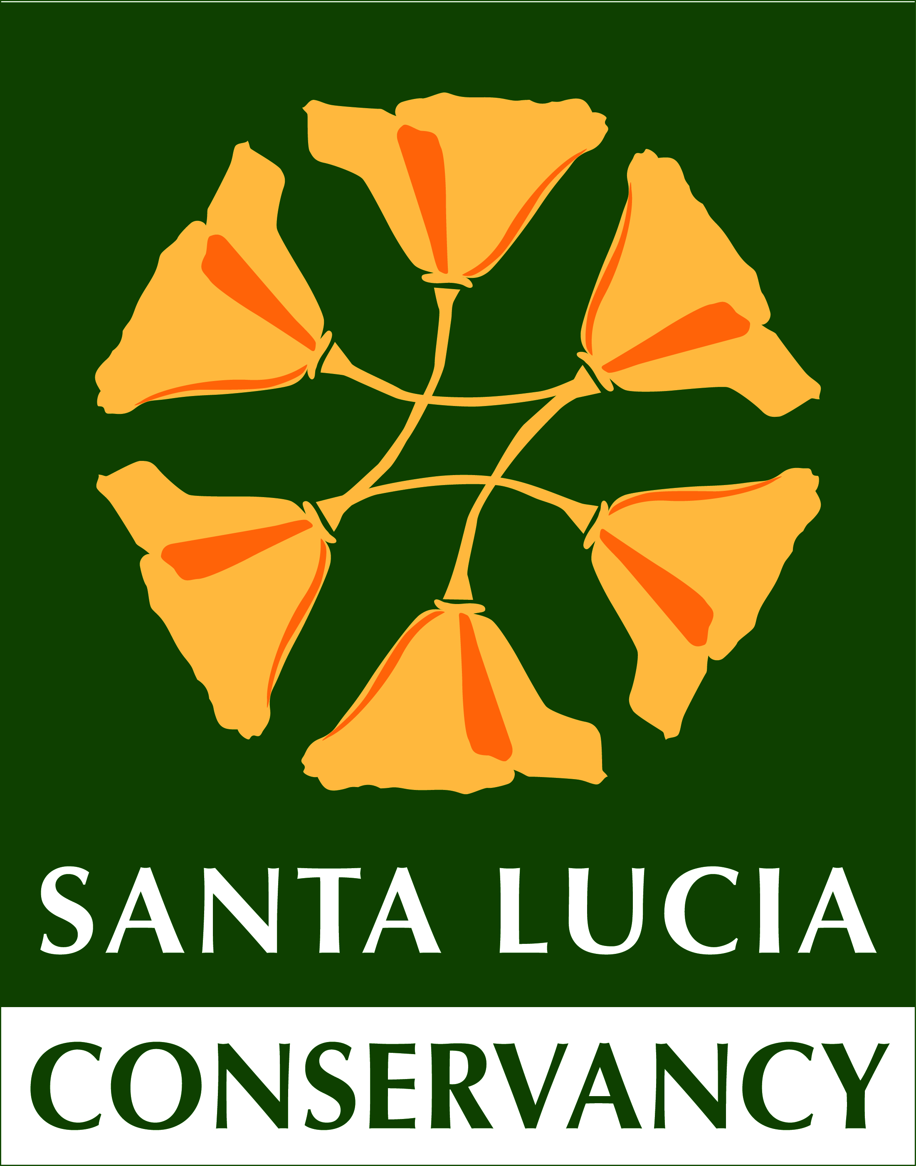

The Santa Lucia Preserve, a private community situated on 20,000 acres of majestic land, is a remarkable conservation community, where 300 families have chosen to permanently protect and collectively manage over 90% of their lands as wild natural habitat.

The Preserve reflects a unique, blended ethos of community, culture and conservation. The Preserve model is unlike any other in America, with a perpetually endowed, independent conservation organization, the Santa Lucia Conservancy, caring for its lands and waters and engaging the families who live here in this work.

The Preserve’s 18,000 acres of protected lands support a rich mosaic of coastal habitats surrounding and interwoven with thoughtfully located homes, inspiring residents to experience nature, conservation efforts and recreational activities, while protecting the beauty and biodiversity of the land for future generations. From native coastal prairies to old-growth redwood groves, wildflower fields to sparkling streams, the iconic landscapes of coastal California are sustained for people and for nature.

The protected lands of the Santa Lucia Preserve provide habitat for over 600 species of native plants and animals, and connect critical pathways for wildlife between the Ventana Wilderness, Los Padres National Forest, Monterey Peninsula Regional Parklands and other nearby protected lands. The Preserve includes the headwaters four of Carmel River’s main tributaries as well as the headwaters of San Jose Creek, which flows directly to the Monterey Bay National Marine Sanctuary. Carmel River is an essential drinking water source for the residents of the Monterey Peninsula, and also sustains threatened steelhead trout, California red-legged frog and many other sensitive species.

For more information, please visit: www.slconservancy.org and www.santaluciapreserve.com or contact Christy Fischer, Executive Director at (831) 206-4319 and cfischer@slconservancy.org

